The Real Story of Globalization

Trade is an economic activity, but its greatest impact may be biological.

Charles C. Mann on stowaway earthworms, far-flung potatoes and the world made by Columbus.
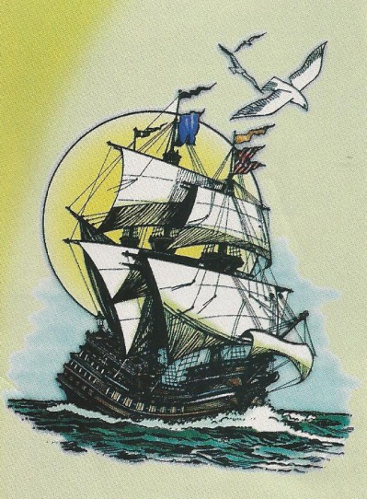
By Charles C. Mann
In the great tropical harbor of Manila Bay, two groups of men warily approach each other, their hands poised above their weapons. Cold-eyed, globe-trotting traders, they are from opposite ends of the earth: Spain and China.
The Spaniards have a big cache of silver, mined in the Americas by Indian and African slaves; the Chinese bring a selection of fine silk and porcelain, materials created by advanced processes unknown in Europe. It is the summer of 1571, and this swap of silk for silver—the beginning of an exchange in Manila that would last for almost 250 years—marks the opening salvo in what we now call globalization. It was the first time that Europe, Asia and the Americas were bound together in a single economic network.
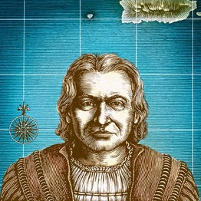
The Legacy of Columbus

A growing number of scholars believe that the ecological transformation set off by Columbus's voyages was one of the establishing events of the modern world.

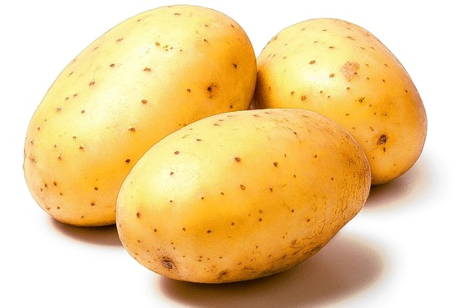
12 WEEKS: Time it took for the potato blight to spread from Flanders to Ireland in 1845
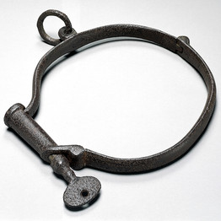
1829: Peak year of the slave trade
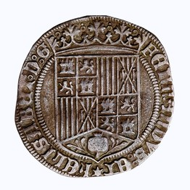
54,000: Tons of silver shipped from the Americas to Europe in the 1700s, up from 17,000 tons in the 1500s

orange slice
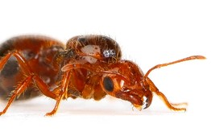
1518: The year an 'infinite number of ants' drove residents from the city of Santo Domingo in Hispaniola

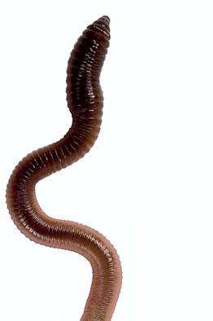
$1.4 BILLION: Value of Italy's 2008 crop of tomatoes, a plant native to South America

36,000%: Increase in tobacco exports from the Chesapeake colonies from 1640 to 1700
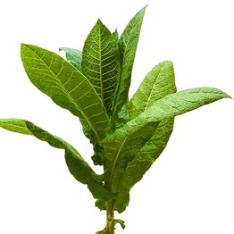
0: Earthworms in North America before 1492
The silk would cause a sensation in Spain, as the silver would in China. But the crowds that greeted the returning ships had no idea what they were truly carrying. We usually describe globalization in purely economic terms, but it is also a biological phenomenon. Researchers increasingly think that the most important cargo on these early transoceanic voyages was not silk and silver but an unruly menagerie of plants and animals, many of them accidental stowaways. In the sweep of history, it is this biological side of globalization that may well have the greater impact on the fate of the world's people and nations.
Some 250 million years ago, the Earth contained a single landmass known as Pangaea. Geological forces broke up this vast expanse, forever splitting Eurasia and the Americas. Over time the two halves of Pangaea developed wildly different suites of plants and animals.
Before Columbus sailed the Atlantic, only a few venturesome land creatures, mostly insects and birds, had crossed the oceans and established themselves. Otherwise, the world was sliced into separate ecological domains. Columbus's signal accomplishment was, in the phrase of the historian Alfred W. Crosby, to reknit the seams of Pangaea.
After 1492, the world's ecosystems collided and mixed as European vessels carried thousands of species to new homes across the oceans. The Columbian Exchange, as Mr. Crosby called it, is why we came to have tomatoes in Italy, oranges in Florida, chocolate in Switzerland and chili peppers in Thailand.
A growing number of scholars believe that the ecological transformation set off by Columbus's voyages was one of the establishing events of the modern world. Why did Europe rise to predominance? Why did China, once the richest, most advanced society on earth, fall to its knees? Why did chattel slavery take hold in the Americas? Why was it the United Kingdom that launched the Industrial Revolution? All of these questions are tied in crucial ways to the Columbian Exchange.
Where to start? Perhaps with the worms. Earthworms, to be precise—especially the common nightcrawler and the red marsh worm, creatures that did not exist in North America before 1492.
Well before the start of the silk-and-silver trade across the Pacific, Spanish and Portuguese conquistadors were sailing the Atlantic in search of precious metals. Ultimately, they exported huge supplies of gold and silver from Bolivia, Brazil, Colombia and Mexico, vastly increasing Europe's money supply. But those homebound ships contained something else of equal importance: the Amazonian plant known today as tobacco.
Intoxicating and addictive, tobacco became the subject of the first truly global commodity craze. By 1607, when England founded its first colony in Virginia, London already had more than 7,000 tobacco "houses"—cafe-like places where the city's growing throng of nicotine junkies could buy and smoke tobacco. To feed the demand, English ships tied up to Virginia docks and took in barrels of rolled-up tobacco leaves. Typically 4 feet tall and 2½ feet across, each barrel weighed half a ton or more. Sailors balanced out the weight by leaving behind their ships' ballast: stones, gravel and soil. They swapped English dirt for Virginia tobacco.
That dirt very likely contained the common nightcrawler and the red marsh worm. So, almost certainly, did the rootballs of plants that the colonists imported. Before Europeans arrived, the upper Midwest, New England and all of Canada had no earthworms—they had been wiped out in the last Ice Age.
In worm-free woodlands, leaves pile up in drifts on the forest floor. Trees and shrubs in wormless places depend on litter for food. When earthworms arrive, they quickly consume the leaf litter, packing the nutrients deep in the soil in the form of castings (worm excrement). Suddenly, the plants can no longer feed themselves; their fine, surface-level root systems are in the wrong place. Wild sarsaparilla, wild oats, Solomon's seal and a host of understory plants die off; grass-like species such as Pennsylvania sedge take over. Sugar maples almost stop growing, and ash seedlings start to thrive.
Spread today by farmers, gardeners and anglers, earthworms are obsessive underground engineers, and they are now remaking swathes of Minnesota, Alberta and Ontario. Nobody knows what will happen next in what ecologists see as a gigantic, unplanned, centuries-long experiment.
Before Columbus, the parasites that cause malaria were rampant in Eurasia and Africa but unknown in the Americas. Transported in the bodies of sailors, malaria may have crossed the ocean as early as Columbus's second voyage. Yellow fever, malaria's frequent companion, soon followed.
By the 17th century, the zone where these diseases held sway—coastal areas roughly from Washington, D.C., to the Brazil-Ecuador border—was dangerous territory for European migrants, many of whom died within months of arrival. By contrast, most West Africans had built-in defenses, acquired or genetic, against the diseases.
Initially, American planters preferred to pay to import European laborers—they spoke the same language and knew European farming methods. They also cost less than slaves bought from Africa, but they were far less hardy and thus a riskier investment. In purely economic terms, the historian Philip Curtin has calculated, the diseases of the Columbian Exchange made the enslaved worker "preferable at anything up to three times the price of the European."
Did the Columbian Exchange cause chattel slavery in the Americas? No. People are moral agents who weigh many considerations. But anyone who knows how markets work will understand the pull exerted by slavery's superior profitability.
Much more direct was the role of the Columbian Exchange in the creation of Great Britain. In 1698, a visionary huckster named William Paterson persuaded wealthy Scots to invest as much as half the nation's available capital in a scheme to colonize Panama, hoping to control the chokepoint for trade between the Pacific and the Atlantic. As the historian J.R. McNeill recounted in "Mosquito Empires," malaria and yellow fever quickly slew almost 90% of the 2,500 colonists. The debacle caused a financial meltdown.
At the time, England and Scotland shared a monarch but remained separate nations. England, the bigger partner, had been pushing a complete merger for decades. Scots had resisted, fearing a London-dominated economy, but now England promised to reimburse investors in the failed Panama project as part of a union agreement. As Mr. McNeill wrote, "Thus Great Britain was born, with assistance from the fevers of Panama."
But Scots could hardly complain about the consequences of the Columbian Exchange. By the time they were absorbed into Britain, their daily bread, so to speak, was a South American tuber now familiar as the domestic potato.
Compared with grains, tubers are inherently more productive. If the head of a wheat or rice plant grows too big, the plant will fall over, killing it. There are no structural worries with tubers, which grow underground. Eighteenth-century farmers who planted potatoes reaped about four times as much dry food matter as they did from wheat or barley.
Hunger was then a familiar presence in Europe. France had 40 nationwide food calamities between 1500 and 1800, more than one every decade, according to the French historian Fernand Braudel. England had still more. The continent simply could not sustain itself.
The potato allowed most of Europe—a 2,000-mile band between Ireland and the Ukraine—to feed itself. (Corn, another American crop, played a similar role in Italy and Romania.) Political stability, higher incomes and a population boom were the result. Imported from Peru, the potato became the fuel for the rise of Europe.
The sweet potato played a similar role in China. Introduced (along with corn) from South America via the Pacific silver trade in the 1590s, it suddenly provided a way for Chinese farmers to cultivate upland areas that had been unusable for rice paddies. The nutritious new crop encouraged the fertility boom of the Qing dynasty, but the experiment soon went badly wrong.
Because Chinese farmers had never cultivated their dry uplands, they made beginners' mistakes. An increase in erosion led to extraordinary levels of flooding, which in turn fed popular unrest and destabilized the government. The new crops that had helped to strengthen Europe were a key factor in weakening China.
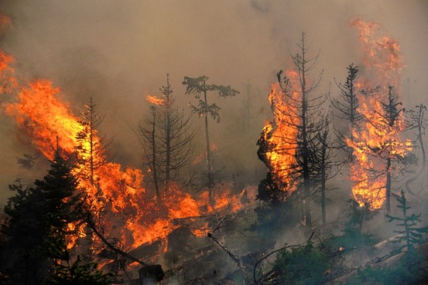
American forests are being devastated by foreign pests—and forests full of dead trees are prone to catastrophic fires. A fire in Washington State.
The Columbian Exchange carried other costs as well. When Spanish colonists in Hispaniola imported African plantains in 1516, the Harvard entomologist Edward O. Wilson has proposed, they also brought over some of the plant's parasites: scale insects, which suck the juices from banana roots.
In Hispaniola, Mr. Wilson argues, these insects had no natural enemies. Their numbers must have exploded—a phenomenon known as "ecological release." The spread of scale insects would have delighted one of the region's native species: the tropical fire ant, which is fond of dining on the sugary excrement of scale insects. A big increase in scale insects would have led to a big increase in fire ants.
This is only informed speculation. What happened in 1518 and 1519 is not. According to an account by a priest who witnessed those years, Spanish homes and plantations in Hispaniola were invaded by "an infinite number of ants," their stings causing "greater pains than wasps that bite and hurt men." Overwhelmed by the onslaught, Spaniards abandoned their homes to the insects, depopulating Santo Domingo. It was the first modern eco-catastrophe.
A second, much more consequential disaster occurred two centuries later, when European ships accidentally imported the fungus-like organism, native to Peru, that causes the potato disease known as late blight. First appearing in Flanders in June 1845, it was carried by winds to potato farms around Paris in August. Weeks later it wiped out fields in the Netherlands, Germany, Denmark and England. Blight appeared in Ireland on Sept. 13.
The Irish were more dependent on potatoes than any other Western nation. Within two years, more than a million died. Millions more fled. The nation never regained its footing. Today Ireland has the melancholy distinction of being the only nation in Europe, and perhaps the world, to have fewer people within the same boundaries than it did more than 150 years ago.
The Columbian Exchange continues to this day. The Pará rubber tree, originally from Brazil, now occupies huge swathes of southeast Asia, providing the latex necessary to make the tires, belts, O-rings and gaskets that invisibly maintain industrial civilization. (Synthetic rubber of equal quality still cannot be practicably manufactured.)
Asian rubber plantations owe their existence to a British swashbuckler named Henry Wickham, who in 1876 smuggled 70,000 rubber seeds from Brazil to London's Kew Gardens. Rubber-tree plantations are next to impossible in the tree's Amazonian home, because they are wiped out by an aggressive native fungus, Microcyclus ulei. Much as the potato blight crossed the Atlantic, M. ulei will surely make its way across the Pacific one day, with consequences as disastrous as they are predictable.
Species have always moved around, taking advantage of happenstance or favorable circumstances. But the Columbian Exchange, like a biological Internet, has put every part of the natural world in contact with every other, refashioning it, for better or worse, at a staggering rate.
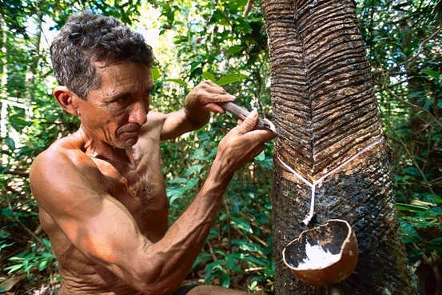
In Southeast Asia, rubber trees now occupy huge swathes of land; plantations are nearly impossible in the tree's Amazonian home because of a native fungus. A rubber tapper extracts latex in Brazil, above. Getty Images
The consequences are as hard to predict as those of globalization itself. Even as plantations of Brazilian rubber take over tropical forests in Southeast Asia, plantations of soybeans, a Chinese legume, are replacing almost 80,000 square miles of the southern Amazon, an area almost the size of Britain. In dry northeastern Brazil, Australian eucalyptus covers more than 15,000 square miles. Returning the favor, entrepreneurs in Australia are now attempting to establish plantations of açaí, a Brazilian palm tree whose fruit has been endorsed by celebrities as being super-healthful.
All of these developments will yield positive economic results—soy exports, for instance, are making Brazil into an agricultural powerhouse, lifting the fortunes of countless poor farmers in remote places. But the downside of the ongoing Columbian Exchange is equally stark. Forests in the U.S. are being devastated by a host of foreign pests, including sudden oak death, a cousin of potato blight that is probably from southern China; the emerald ash borer, an insect from northern China that probably arrived in ship pallets; and white pine blister rust, a native of Siberia first seen in the Pacific Northwest in 1920.
Forests full of dead trees are prone to catastrophic fires, a convulsive agent of change. New species will rush in to replace those that are lost, with effects that cannot be known in advance. We will simply have to wait to see what kind of landscape our children will inherit.
Today our news is dominated by stories of debt deals and novel computer applications and strife in the Middle East. But centuries from now, historians may well see our own era as we have started to see the rise of the modern West: as yet another chapter in the unfolding tumult of the Columbian Exchange.
—Mr. Mann is the author of "1493: Uncovering the New World Columbus Created," which will be published next week.

- With the conquering of the Aztecs and Inca populations (along with other indigenous peoples), what system of social structure do you predict will take shape in the Americas?

- Do you believe this social structure will be able to sustain itself? What are the advantages? What are the challenges?

